

Connectivity Scenario of 3D PAY Merchants with Their Own Hosted Payment Page

Table of Contents

1. Change History 3
2. Audience 4
3. Transaction part 4
3.1. “3D PAY” models scheme 4
3.2. Buying steps 5
3.3. Two transaction integration models in short 5
4. Merchant administration 6
5. Merchant integration with NestPay transaction and back-office system 6
5.1. Downloading the manuals form Merchant Center (test) 6
5.2. Development of Merchant system 7
5.3. Checking/changing Store Key and creating API role user 7
5.4. Test Merchant system 7
5.5. Switch to production 7
6. Notes: 8
7. Abbreviations 8

Change History

The following table shows the history of document changes.

Document  version | Description | Totall Number of Pages | Issue Date | Author
1.0 | Initial Version |  | 3th February 2016 | New Channels team

Audience

Those are the merchants who have their own payment pages or if they are providing them to the merchants.

Transaction part

For merchants “3D PAY” model is for bigger merchants and Internet Payment Service Providers who will have their own payment page. They will make 3-D Secure authentication and authorization separately.
The main characteristics of this way of integration are:
- payment page is on Merchant or IPSP side
- card holder data are collected on Merchant
- Merchant back-office system could be integrated with NestPay back office system

“3D PAY” models scheme

Ecommerce buying steps for “3D PAY” models are described on below scheme:
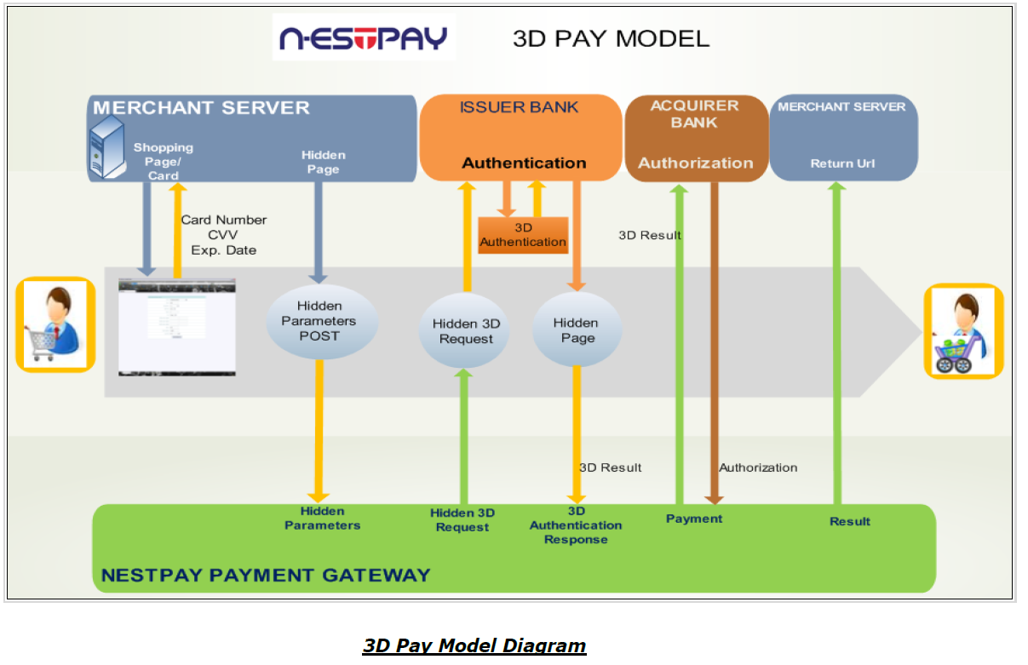
Note: payment page is on merchant or IPSP
“3D PAY Model Diagram” represents buying steps, starting from the most left to the right.

Buying steps

“3D PAY” model on Diagram:
- Customer fills the shopping cart with products and is redirected to Merchant’s payment page
- merchant sends HTTP POST request to NestPay with all mandatory and optional parameters
- NestPay sends “Hidden 3D PAY Request”, trough Customer browser, to card Issuer bank for 3D secure authentication
- Issuer bank sends “Hidden Page” to NestPay with 3-D Secure authentication result
- NestPay sends “Authorization” request to BIB authorization system with values from 3-D Secure authentication response
- BIB authorization system sends “Authorization” response to NestPay
- NestPay sends “HTTP POST Response” to Merchant system

integration model in short

In “3D PAY” model HTTP POST request should be sent to NestPay 3D service TEST link
https://testsecurepay.intesasanpaolocard.com/fim/est3dgate
for 3-D Secure authentication check.

Note: for PRODUCTION link is https://bib.eway2pay.com/fim/est3Dgate

“3D PAY” HTTP POST requests are described in “ISPC_Nestpay_Merchant_Integration_3D_Pay.pdf” manual:
- “3D PAY” model enables processing of 3-D Secure card transactions and authorization:
  - HTTP POST method is supported for merchant integration
  - credit card page is hosted by the merchant
  - payment is done automatically by NestPay
- The customer personal information is entered on Merchant side, therefore Merchant must pass PCI DSS certification.
- beside mandatory fields the Merchant can POST to NestPay optional data, such as username, user email or user address
The Result of 3-D Secure authentication check and authorization will be in NestPay response to Merchant URL.

However, it’s possible for the merchants to void, refund, to make post-authorization or to check order status by sending API requests to NestPay. For mentioned transaction types API requests should be sent to TEST link https://testsecurepay.intesasanpaolocard.com/fim/api.

Note: for PRODUCTION link is https://bib.eway2pay.com/fim/api

How to generate API requests for some order is described in “ISPC_Nestpay_Merchant Integration API Manual.pdf” manual:
  - Secondary transactions (post-authorization, void, refund)
  - Order status query
  - Order history query
Note: Names for types of authorization and following transaction messages in comparison to other used names:
- preauthorization = preauthorization/authorization with completion
- auto-postauthorization/sale = authorization/ authorization without completion
- postauthorization = completion
- void = reversal/cancellation transaction
- refund = refund
- order status query = authorization check status/completion check status

Merchant administration

Merchant administration back-office system is NestPay Merchant Center.

There are two instances of Merchant Center:
- TEST https://testsecurepay.intesasanpaolocard.com/bib/report/user.login
- PRODUCTION https://bib.eway2pay.com/bib/report/user.login

It is used for:
- administration:
  - orders
  - transactions
  - users
  - merchant parameters for connection to NestPay transaction system
- searching:
  - downloading needed documents for integration with NestPay transaction system
  - bank information
  - help
and many other things related to NestPay transaction system. Details can be found in “Inhouse_NestPay_MerchantCenterUserManual.pdf” manual.

Merchant integration with NestPay transaction and back-office system

In following paragraphs will be described the main steps of merchant integration, with links and documents for integration.

Downloading the manuals form Merchant Center (test)

Login to test Merchant Center with Merchant Id, Username and Password for Merchant Administrator role provided by BIB on TEST link https://testsecurepay.intesasanpaolocard.com/bib/report/user.login and download the manuals.

Note: for PRODUCTION link is https://bib.eway2pay.com/bib/report/user.login

There are three main manuals:
- “ISPC_Nestpay_Merchant_Integration_3D_Pay.pdf” - transaction manual for 3-D Secure HTTP POST requests and responses with explanations of mandatory/optional parameters and examples
- “ISPC_Nestpay_Merchant Integration API Manual.pdf” - transaction manual for authorization API requests and responses with explanations of mandatory/optional parameters and examples
- “Inhouse_NestPay_MerchantCenterUserManual.pdf” - merchant administration manual for Merchant Center back-office system
- “Merchant Integration Test Cases and Test Cards - eway2pay_3D_PAY_vx.y.xls” - list of test cases and needed card data for testing of merchant integration, where “…vx.y…” is version of the document (e.g. “…v1.0…” denotes “version 1.0” of the manual)

Development of Merchant system

Develop test system for integration with NestPay transaction system following rules and examples from downloaded manuals.
Merchant should send all mandatory data listed in “ISPC_Nestpay_Merchant_Integration_3D_Pay.pdf” for “3D PAY” mode and “ISPC_Nestpay_Merchant Integration API Manual.pdf” for API mode. Those data are collected on Merchant payment page. There are also optional data mentioned in those manuals which could be sent to NestPay.
While developing merchant site and payment page Merchant must follow rules provided by BIB. Before production BIB will check Merchant site and payment page.

Checking/changing Store Key and creating API role user

For making 3-D Secure authentication check with “3D PAY” model Merchant ID, already provided in one of previous steps, and Store Key are needed. Store Key could be found in Merchant Center TEST link https://testsecurepay.intesasanpaolocard.com/bib/report/user.login under Administration tab Change Store Key link in Old Store Key parameter.

For making API authorization requests with “API” model must be created new API role user Merchant Center on TEST link https://testsecurepay.intesasanpaolocard.com/bib/report/user.login.

In Merchant Center go to Administration tab Add New User link and enter all data about API user with mandatory “API User” Role selected.
This is mandatory because API role user password never expires. API role user have no rights to login to Merchant Center and it’s used only for making API requests.

Note: Merchant Center for PRODUCTION is https://bib.eway2pay.com/bib/report/user.login

Test Merchant system

Merchant administrator must make mandatory test cases with test cards by sending request to “3D PAY” TEST service https://testsecurepay.intesasanpaolocard.com/fim/est3Dgate for 3-D Secure authentication (only for MasterCard, Maestro and VISA cards)

Note: for production PRODUCTION link is https://bib.eway2pay.com/fim/est3Dgate

After that, in second step, authorization message is sent to API TEST service https://testsecurepay.intesasanpaolocard.com/fim/api.

Note: for PRODUCTION link is https://bib.eway2pay.com/fim/api

Test cases and Test cards could be downloaded from Merchant Center TEST link https://testsecurepay.intesasanpaolocard.com/bib/report/user.login in Documents under Help panel. Which test cases are mandatory for the Merchant depends on functionalities and transaction types used by merchant. After all mandatory tests are done Merchant should contact BIB to approve test process. If some test is failed then must be repeated.

Switch to production

When all previous steps are successfully finished Merchant will get production parameters (Merchant Id, User Name and Password) from BIB, also merchant should repeat step “Creating Api Role User” in production environment and after that will be switched to production. Before that Merchant can’t make production transactions.

Notes:
- Do not use Test cards on production environment
- For any question related to integration BIB contact information on Merchant Center TEST https://testsecurepay.intesasanpaolocard.com/bib/report/user.login or PRODUCTION https://bib.eway2pay.com/bib/report/user.login login page could be found
- The Merchant security parameters (Merchant ID, User Name and Password) are different for test and production environment

Abbreviations

IPSP = internet payment service provider with more than one merchant connected to its system
MPI = merchant plug-in
3-D Secure authentication = secure way of card holder authentication (usually one time password) on the bank which issued the card used for payment in ecommerce transaction
NestPay = new ecommerce platform service for BIB merchants provided by Intesa Sanpaolo Card
ISPC = Intesa Sanpaolo Card

